Learning Journal Entry 1:

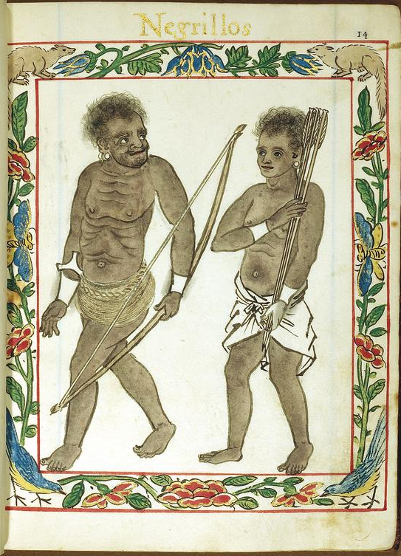

The above is a Spanish drawing from 1595, depicting what they coined as ‘Negritos’, or little black people. To me, this suggest that the Spanish considered themselves above them when they gave this classification. It makes sense, as the Spanish would have been well dressed in the 1600s, but the artist depiction was that similar to the cave people. I guess, due to this ‘above them’ feeling that the Spanish had, they just lumped a whole chunk of people together just because of looks without thinking that they had different tribes or languages. Even though Europe itself is similar to the Negritos, with similar looking people but different languages.

Learning Journal Entry 2:

The notion of ‘thinking’

Throughout the course, Kelvin has repeatedly mentioned this term thinking. I didn’t believe that thinking was so difficult until this course, where thinking has to be used for almost everything, but mainly to critic. To me, this is just weird, as I am more of the go with the flow kind. Where did this motion of criticizing come from? It basically means every source is unreliable and we ourselves have to consider whether to use it. Furthermore, I feel that thinking is something that hinges on whether one has an interest in the topic at hand. If there is completely zero interest, then there is simply no reason to spend time thinking. So, thinking is hard, especially if we think about everything. Maybe that’s why autopiloting is so nice, because there is simply no reason to think.

Learning Journal Entry 3:

Thomas Stamford Raffles

Raffles has indeed made significant contributions to the founding of Singapore. However, I find it weird how the Singapore Government has made it so that he is without flaws. This is in spite of countless sources. My understanding of Raffles was that he was this unreasonable boss that steals credit from his underlings (Farquhar), and does what he wants. However, there has been a different light painted by the Singapore Government to future Singaporean students. I was also surprised to know about the Sayid Yasin Incident, as there was no mention of it happening. It served its purpose of forcing the temenggong to concede to Raffles’ demands, but we cannot deny that it was cruel. Maybe Raffles was just a brilliant backstabbing opportunist that allowed him to rise up the ranks so quickly at his young age.

Sort of like office politics?

Learning Journal Entry 4:

Race

Race is a significant portion of Singapore, being emphasized by the government countless of times. However, I feel that it has no reason still being classified. Race after all is a social construct, and that can be changed with time. What is the reason that we have to classify each other under a group, but still collectively refer to each other as Singaporeans? The Singapore Government have embraced being multiracial and multireligious as part of the Singapore identity. However, there has been increase in interracial marriages and children. As the lines being race are blurred, the classification becomes less accurate. Race is probably a social construct that was carried over from the British, as evident that they segregated each race by their own towns in their town plan.

Learning Journal Entry 5

Subjectivity

This term has been repeated many times throughout this mod. Subjectivity to me is just using what I feel and think to express myself on a topic. However, coming from an engineering major, I prefer facts than opinions. I know that Kelvin has insisted facts don’t exist, but to me, if it is so indisputable, there must come a point where an extreme opinion becomes fact, like for example math (1 + 1 = 2). Facts to me is subjectivity brought to its limits that it cannot be challenged at this given time. Sure, you can challenge the fact and change it, like how Galileo attempted to for his heliocentric model, but that does not change that the geocentric model is the fact of that time. Maybe next time some new thinking will come up that 1 + 1 is not equals to 2, but for now, that is an indisputable fact. We should instead call this an evolution of facts rather than terming it as subjective opinion that is widely accepted. If not, there will be no end if everyone has to question whether this subjective opinion is acceptable or not.